Game Mechanics:

Game Genre: Rpg, Top-down Game

1. 1 map with 6 scenes (not included the game over scene and menu scene)

2. 1 boss at final stage, each scenes has mobs starting from scene 2

3. chest with money, instead of weapons and gears

4. 1 level.

5. can use potions ( heal only )

6. has battle mechanics

7. score system

8. leaderboard/best score

9. audio system

10. 1 class (Sword Knight)

add ons:

* inventory system
* and equipement system

Theme: Dark Fantasy

Title of the Game: 7 Scared Swords

Plot: A lone hero who travels around the world to gather all 7 sacred sword to defeat

the evil demon king.

Description: Defeat all 7 bosses to get each 7 sacred sword and defeat the evil demond king.

Paolo:

Design:

Maps

Mobs

Audio

Gem:

Pixel Character

Pixel Boss

Ken:

Design:

Title screen

Game Menu

In game play

Sample Designs:

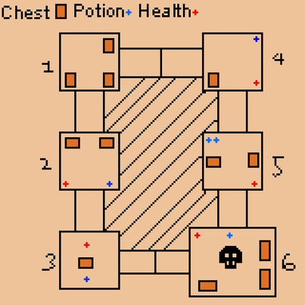  
  
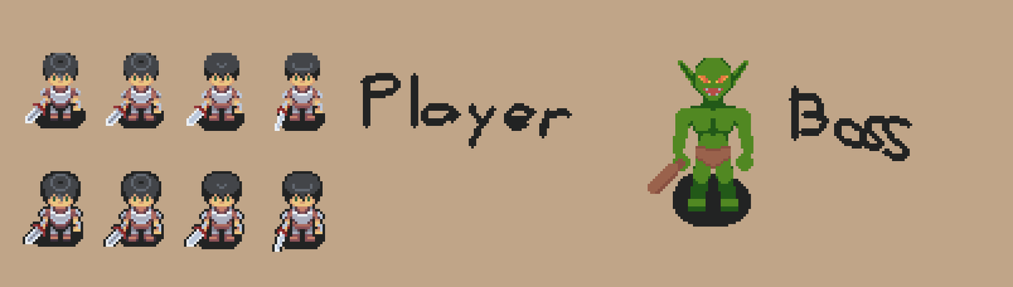can be change, still on planning phase